**Profit Analysis - Capstone Project**

View 1: Profit by Region using Shapes

* The sheet should only display the Total Profit in thousands along with the Region headers.
* Use the USA map icon for each region as seen in the expected view. Note: For this, the map icon should be saved under Shapes in the “My Tableau Repository” folder. Then you need to go to Tableau Desktop and reload shapes for this to get appeared.
* Enable Action Filters.
* Place the Profit values inside the map, and most important, if the profit is positive, then display the values in Green. Else, display them in Red to indicate Loss as seen in the Central Region.
* I have attached the image for the map icon, in case you don’t find one of your choices, feel free to use the below:



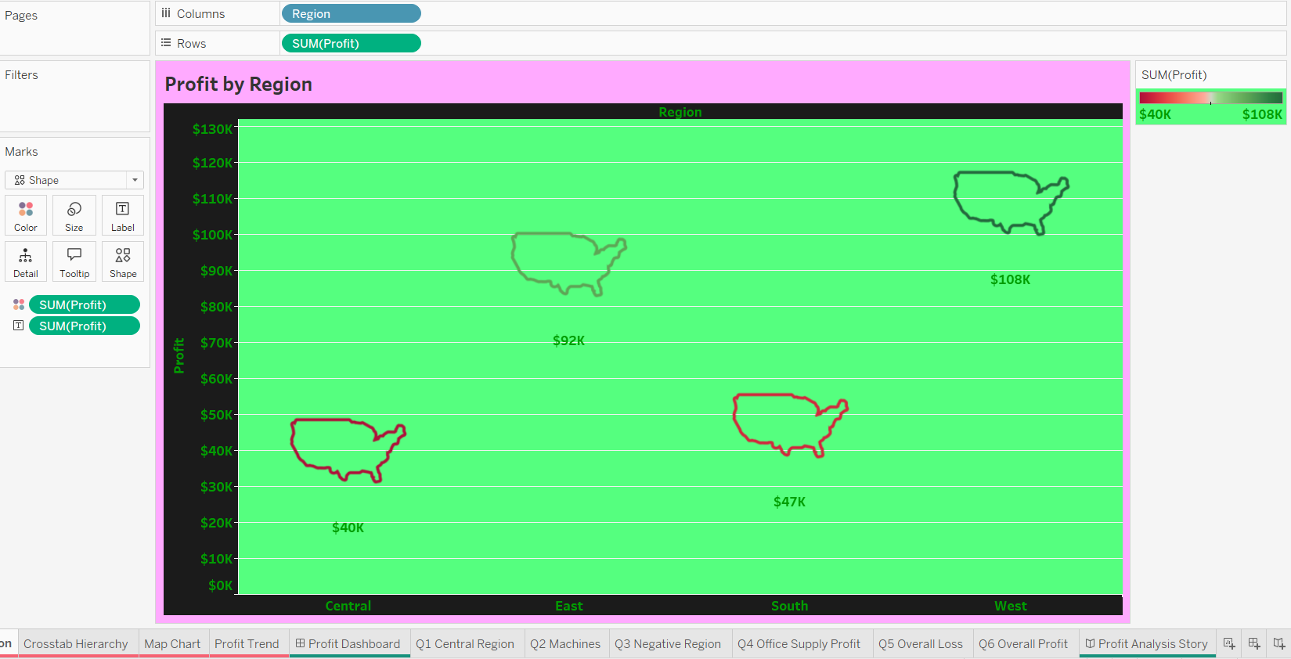

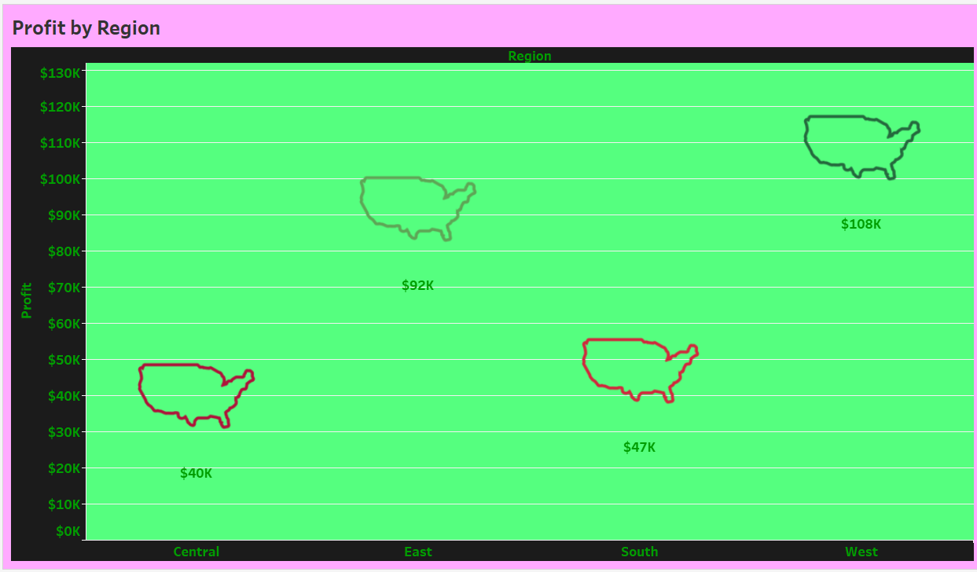

View 2: Crosstab

* Create a hierarchy in the order Category>Sub-Category>Ship Mode.
* Build a cross tab showing Category by Profit, Quantity, and Sales.
* The view should be Column Grand Totals and Sub-totals on expanding the hierarchy.
* Subtotals and Grand totals should be shaded with different colors.
* Enable Action filters.
* Display profit and sales in dollars and display in thousands (K) units with no decimals.

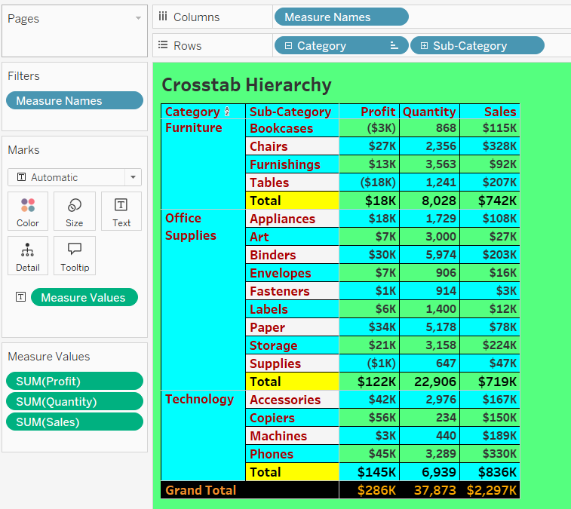



View 3: Map Chart

* Build a Map Chart showing profit across all the states.
* Use Red Green diverging to show Profit (Green) and Loss (Red) in a filled map.
* Tooltip should show State and should display profit in green if positive, else, red to indicate the loss.
* Enable Action filters.

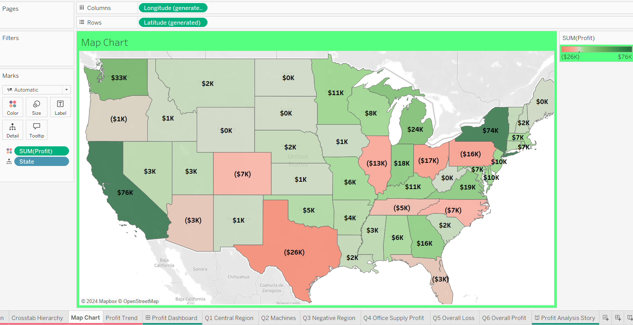

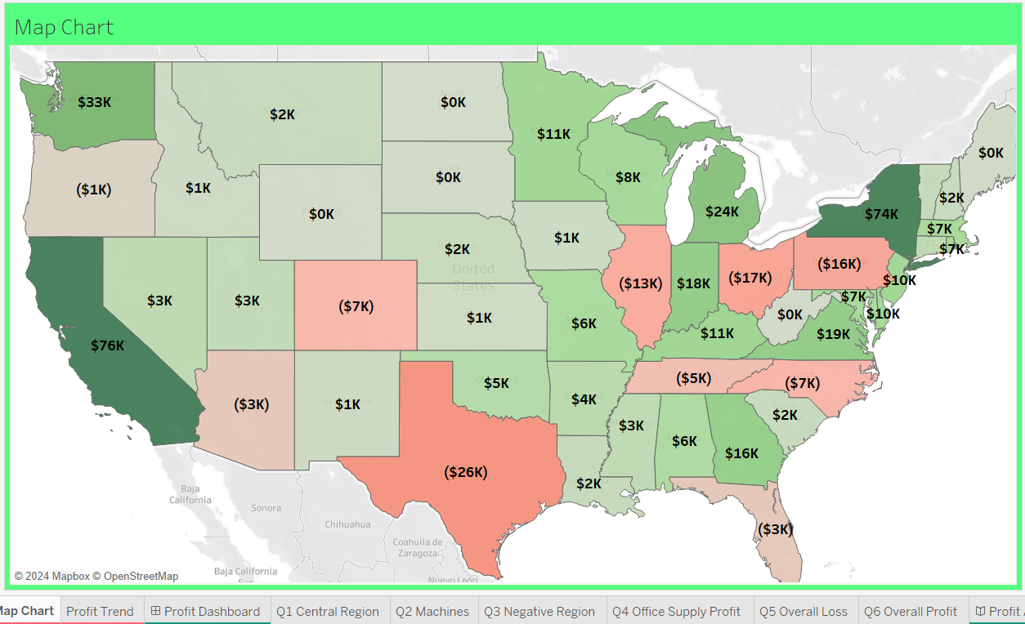

View 4: Line Chart

* Continuous line Chart should display the Profit trend by Month-year.
* X-axis should display the month year in the format MMM YY. For example, Mar 22 [Year 2022].
* Hide the Axis Titles only.
* Tooltip should display only Month-year along with the sales value in $ in Thousands (K).
* Use Order Date as a Date Range filter.
* Name the sheet as shown below and color the tab.

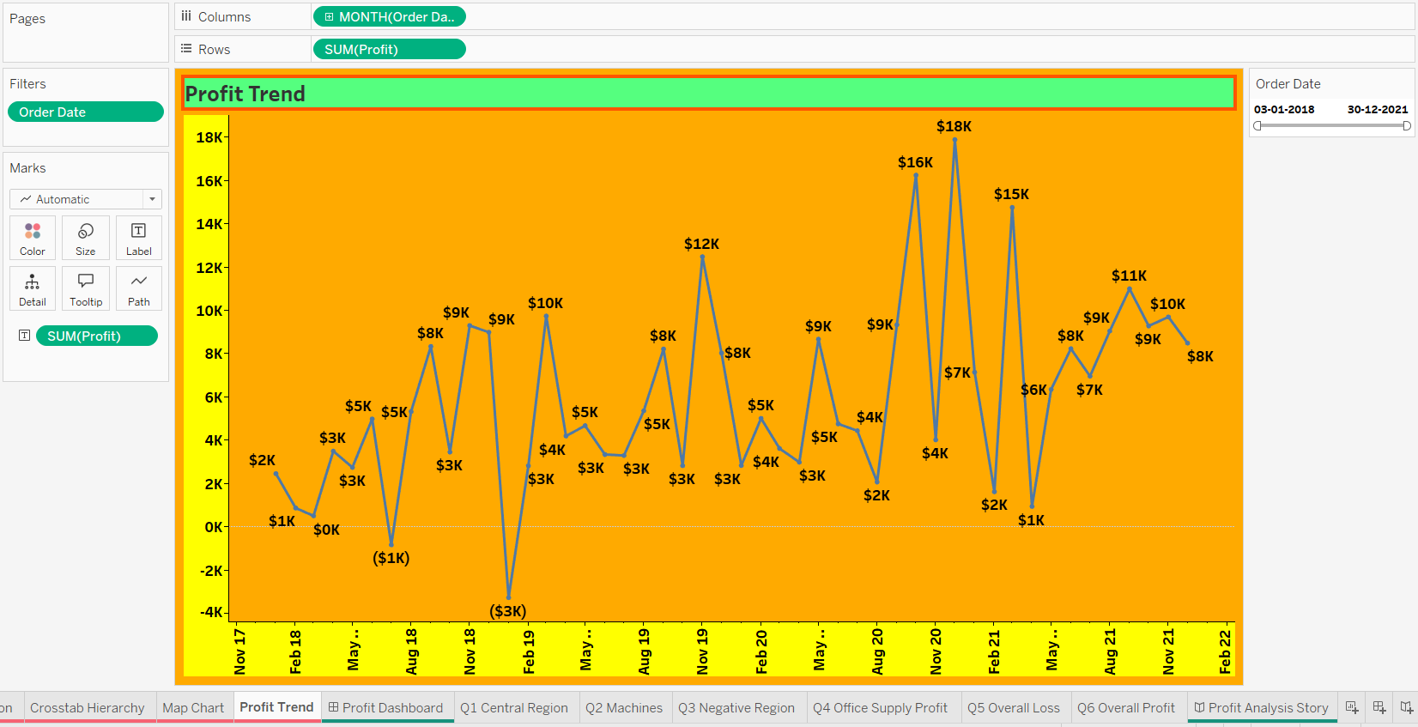

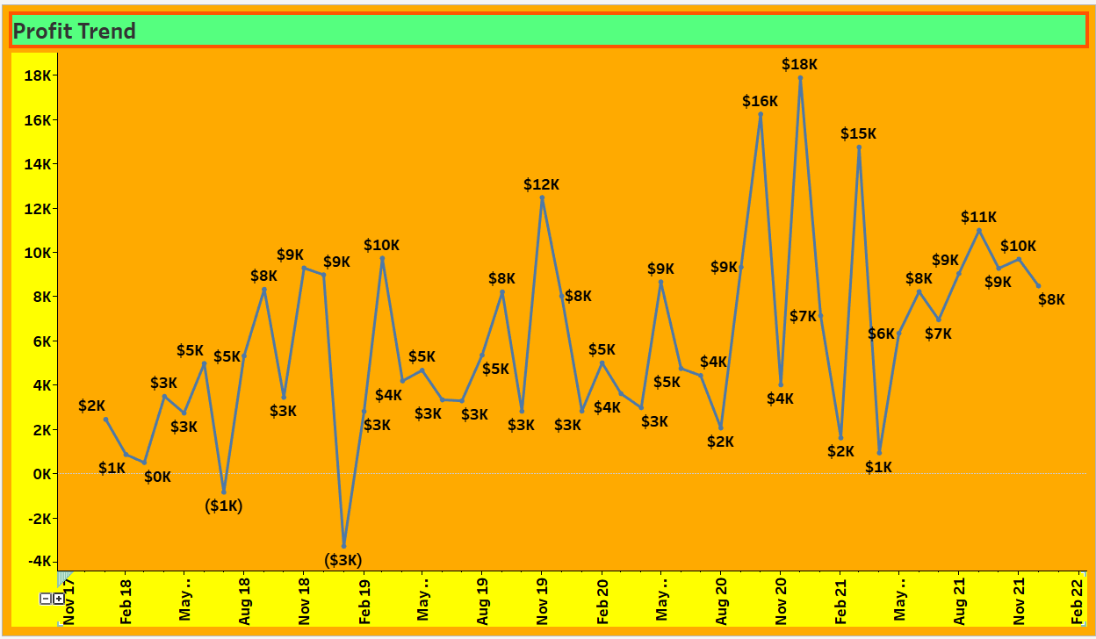

**Dashboard**

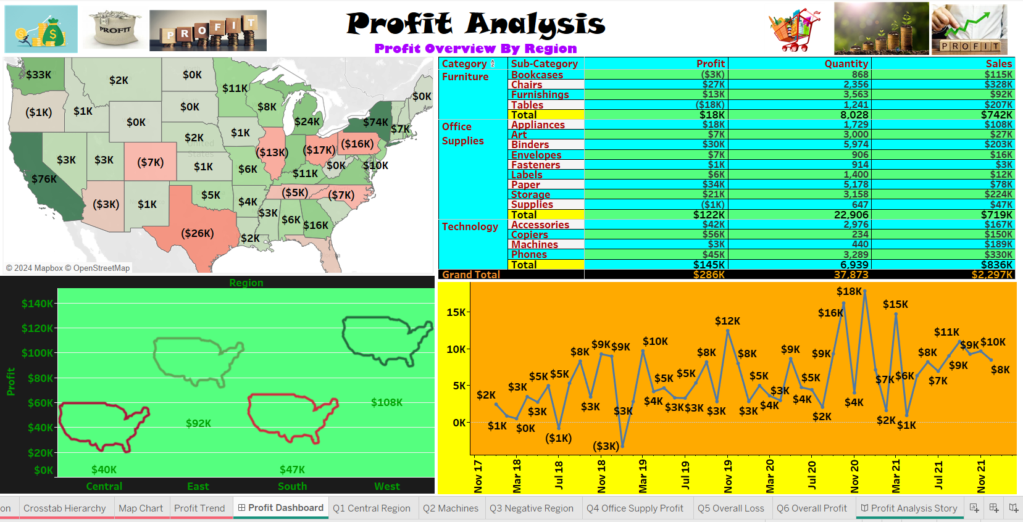

**Answer the below questions**  
  
Q1. In the Central region, which states suffered losses? Also, this should be answered using Action filters with the screenshot.

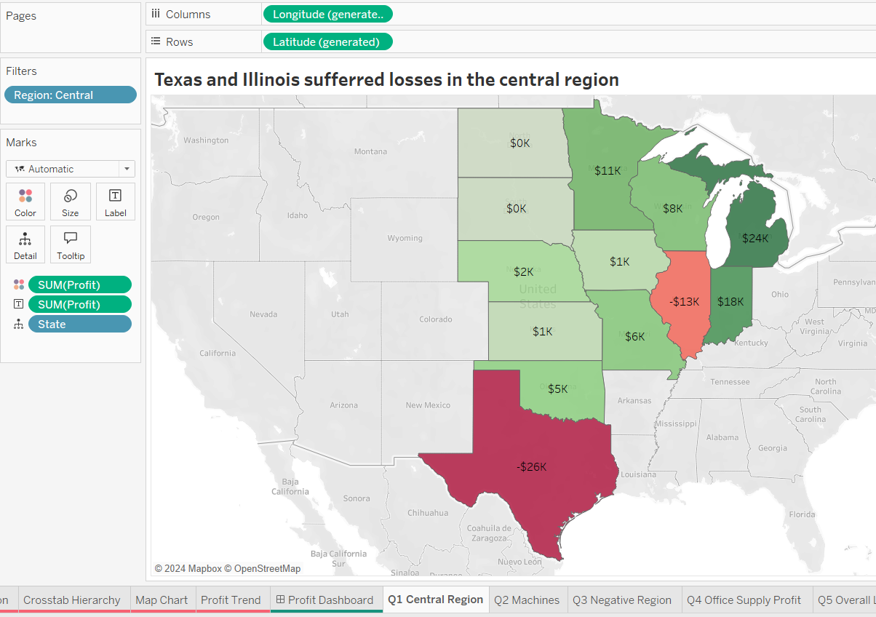

Q2. Under Machines for Same Day ship mode, which state has the highest loss?

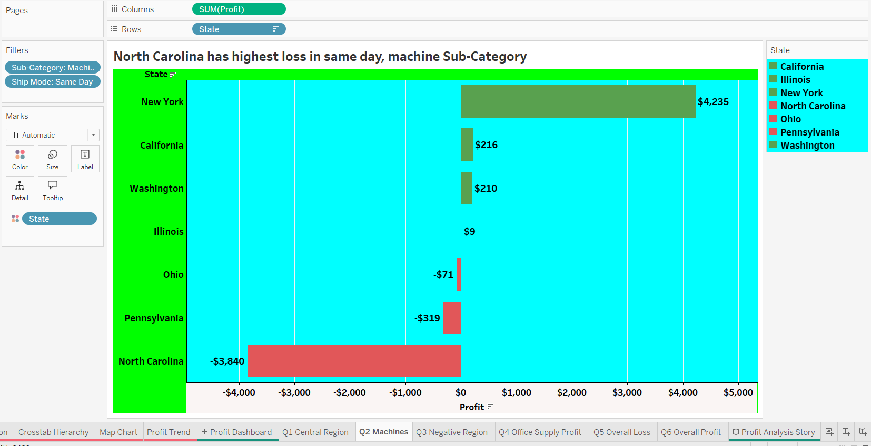

Q3. For which Category and Region do we have negative profit?  
Attach more than one screenshot if applicable.

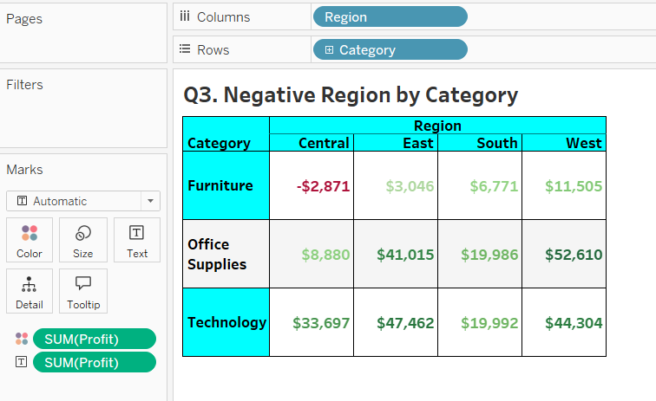

Q4. From September 2020 to December 2020, what is the total profit for Office Supplies?

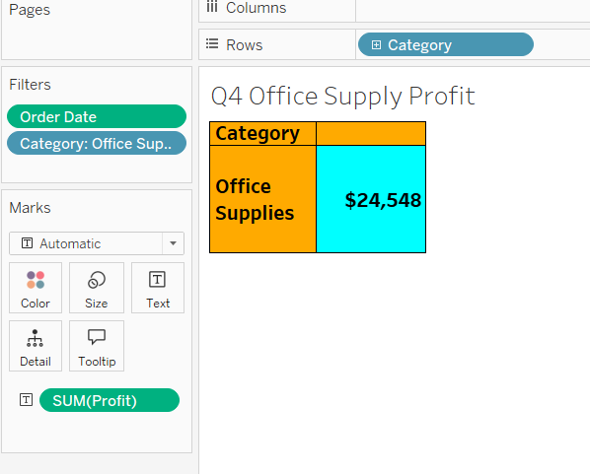

Q5. From September 2020 to December 2020, in the Central region, which Subcategories, when broken down by Ship Mode have reported an overall loss along with their values (Subtotal)?

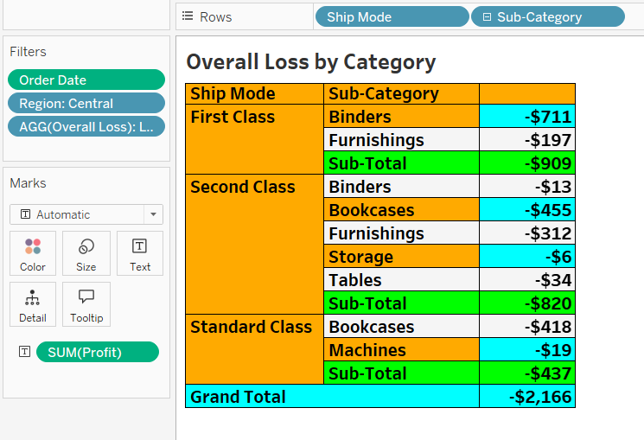

**Q6. What is Net profit by Category for Oregon and Ohio taken together?**

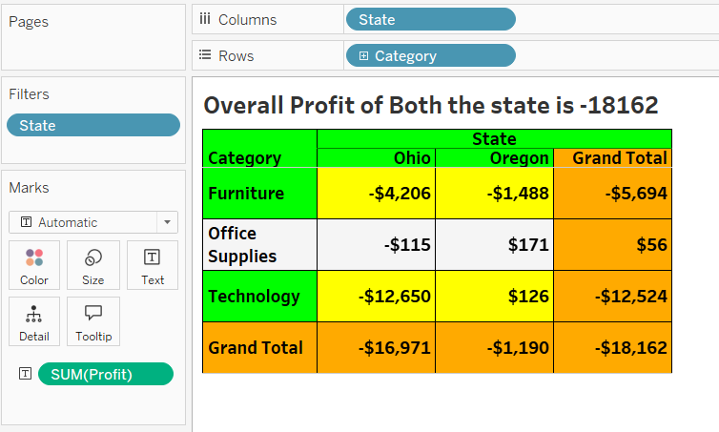

**Profit Analysis Story**

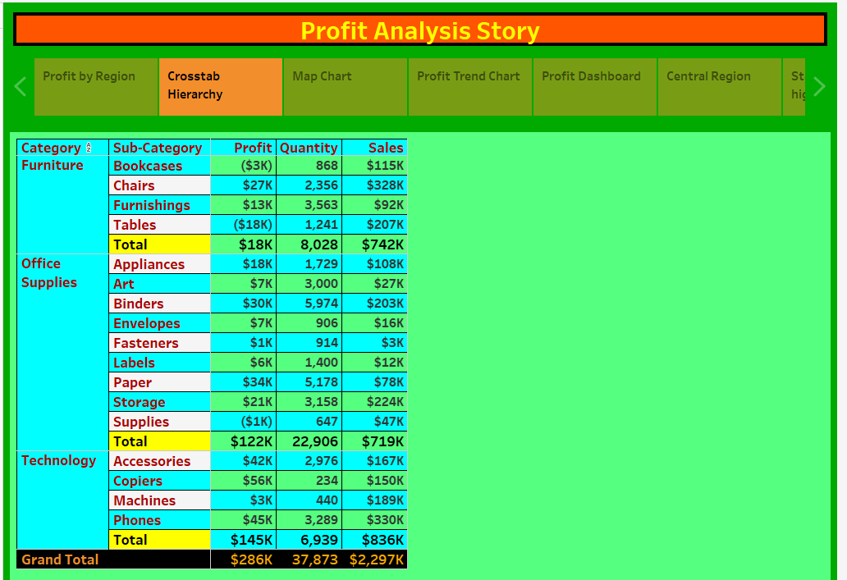

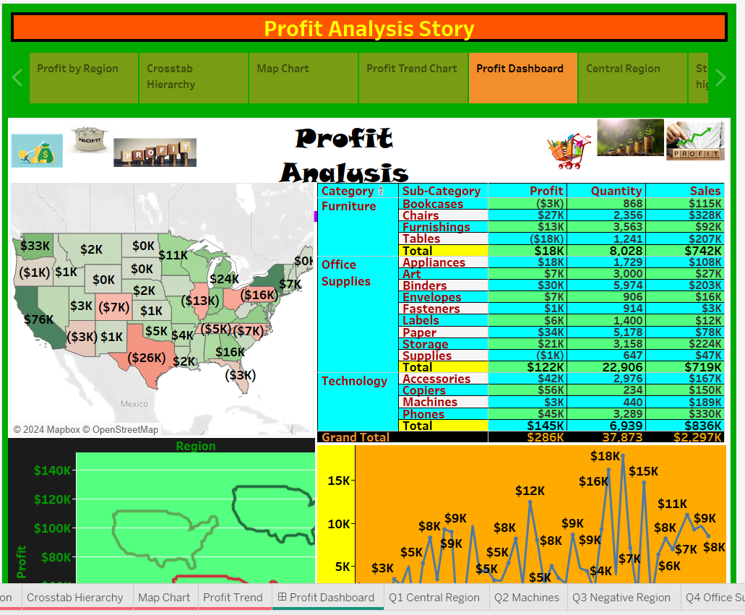

**Tableau Publishing**

